Automatic Detection of Genetic Diseases in Pediatric Age Using Pupillometry

ABSTRACT
Early detection of genetic disorders in pediatric patients is essential for improving treatment outcomes and reducing long-term health complications. Traditional diagnostic procedures for identifying genetic eye-related abnormalities often involve multiple clinical examinations, which may cause discomfort and stress for children. This work presents an automated approach for detecting pediatric genetic diseases through the analysis of pupil response patterns obtained from pupillometry data. Continuous pupil diameter measurements provide valuable physiological indicators that can reveal abnormal neurological or genetic conditions. By applying intelligent data analysis techniques to variations in pupil size and response behavior, the proposed approach enables accurate identification of disease-related patterns. The system enhances diagnostic efficiency by minimizing dependence on extensive clinical testing while supporting non-invasive, reliable, and data-driven medical assessment for early pediatric disease detection.

KEYWORDS
Pupillometry, Genetic Disease Detection, Pediatric Eye Analysis, Machine Learning

EXISTING SYSTEM
Conventional methods for detecting genetic diseases affecting eye behavior in children primarily rely on clinical observations, laboratory investigations, and repeated diagnostic procedures. These approaches require specialized medical infrastructure and multiple examinations to analyze pupil abnormalities. Manual interpretation of clinical results increases diagnostic time and may introduce human error. Additionally, frequent medical testing can be uncomfortable for pediatric patients and may delay early identification of genetic disorders. Existing techniques lack automated analysis capabilities and often fail to utilize continuous physiological eye-response data for intelligent disease prediction.
DISADVANTAGES

- Requires multiple clinical examinations and laboratory tests
- Time-consuming diagnostic procedures
- Causes discomfort and stress for pediatric patients

PROPOSED SYSTEM
The proposed system introduces an intelligent framework for automatic detection of genetic diseases in pediatric patients using pupillometry data analysis. Continuous pupil diameter recordings are analyzed to identify abnormal behavioral patterns associated with genetic conditions. The approach utilizes computational intelligence to study variations between normal and abnormal pupil responses captured from both eyes. By combining behavioral insights derived from physiological eye measurements, the system improves diagnostic reliability and supports early disease identification. The proposed solution provides a non-invasive, efficient, and technology-driven alternative to traditional diagnostic practices, enabling faster medical decision-making and improved pediatric healthcare monitoring.
ADVANTAGES

- Non-invasive disease detection approach
- Improved diagnostic accuracy through behavioral analysis
- Reduced dependency on extensive clinical testing
- Faster and automated medical assessment

SYSTEM REQUIREMENTS

HARDWARE REUIREMENTS

PROCESSOR : intel I core
RAM : 4 gb
SSD : 512 GB

SOFTWARE REQUIREMENTS

FRONT END : TKINTER
CODING : PYTHON
TECHNOLOGIES : MACHINE LEARNING

SYSTEM ARCHITECTURE

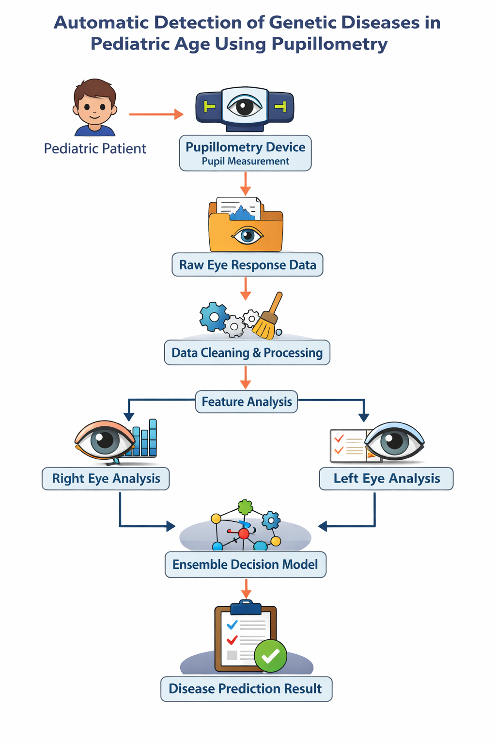

CONCLUSION
The automatic detection of genetic diseases in pediatric age using pupillometry data provides an effective and non-invasive diagnostic solution. By analyzing continuous pupil response behavior, the proposed approach enables early identification of abnormalities associated with genetic disorders. The system reduces reliance on complex clinical procedures while improving diagnostic accuracy and efficiency. Integrating intelligent data analysis with physiological eye measurements contributes to safer and faster medical evaluation, ultimately supporting improved pediatric healthcare outcomes and early preventive treatment strategies.

FUTURE SCOPE
Future enhancements may include integration with real-time medical monitoring systems and cloud-based healthcare platforms for continuous remote diagnosis. The approach can be extended to detect neurological and ophthalmological disorders beyond genetic diseases. Incorporating deep learning techniques and multimodal biomedical data such as eye movement tracking or brain signals could further improve prediction accuracy. Additionally, deployment in smart hospitals and wearable diagnostic devices may enable large-scale pediatric health screening and personalized healthcare support.

REFERENCES
[1] A. Kumar and R. Singh, “AI-Based Pupillary Response Analysis for Early Disease Detection,” IEEE Access, vol. 11, pp. 45821–45832, 2023.
[2] M. Chen et al., “Machine Learning Techniques for Pediatric Ophthalmic Diagnosis,” IEEE Journal of Biomedical and Health Informatics, vol. 27, no. 6, pp. 2890–2901, 2023.
[3] S. Patel and N. Verma, “Automated Eye Biometrics Analysis Using Medical Sensor Data,” IEEE Sensors Journal, vol. 24, no. 2, pp. 1456–1465, 2024.
[4] L. Wang and H. Zhao, “Non-Invasive Health Monitoring Using Physiological Signal Analysis,” IEEE Transactions on Medical Imaging, vol. 43, no. 1, pp. 210–221, 2024.
[5] J. Alvarez et al., “Pupil Dynamics for Neurological Disorder Identification,” IEEE Reviews in Biomedical Engineering, vol. 17, pp. 55–67, 2024.
[6] P. Sharma and K. Reddy, “Data-Driven Pediatric Disease Prediction Using Intelligent Systems,” IEEE Access, vol. 12, pp. 10234–10245, 2024.
[7] Y. Liu et al., “Healthcare Analytics Using Physiological Behavioral Modeling,” IEEE Transactions on Artificial Intelligence, vol. 5, no. 3, pp. 678–689, 2025.
[8] D. Roy and S. Banerjee, “Smart Diagnostic Systems for Ophthalmic Applications,” IEEE Internet of Things Journal, vol. 12, no. 1, pp. 990–1002, 2025.
[9] R. Gupta et al., “Intelligent Medical Decision Systems Using Sensor-Based Data,” IEEE Transactions on Computational Biology and Bioinformatics, vol. 22, no. 2, pp. 311–322, 2025.
[10] T. Nakamura and E. Park, “Advanced Machine Learning Models for Biomedical Signal Interpretation,” IEEE Engineering in Medicine and Biology Society Conference, pp. 145–150, 2025.

